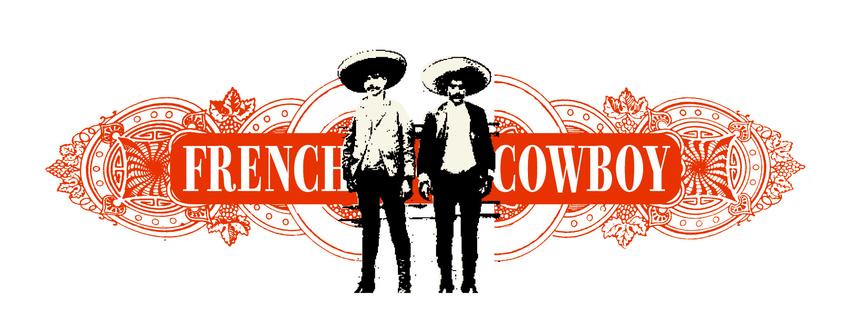

French Cowboy is the new band created by Federico Pellegrini, singer of the late Little Rabbits, one of the milestone french groups of the nineties, which disappeared in 2005, after seven remarkable albums.
Federico Pellegrini plays with three of his mates of allways : Gaëtan Chataigner (bass), Stéphane Louvain (guitar) and Eric Pifeteau (drums). All voices ahead, sparing neither anger or lyricism, they are like some beach boys lost in the Arizona desert, where surfer girls have become characters out of Johnny Cash songs.

Note 1 - Tucson Arizona is not here by chance. This is the consequence of bounds tieds there with Jim Waters, the producer of the last three albums of The Little Rabbits (but also of some of the Jon Spencer Blues Explosion’s albums, for example). Jim Waters mixed Baby Face Nelson Was A French Cowboy, the first album of French Cowboy and tucsonian horn players feature on some songs.
Note 2 - This album has been recorded in 2006, along with Dillinger Girl et Baby Face Nelson, sung by Federico Pellegrini and Helena Noguerra. Some songs are on both discs, with very different arrangements.`
Note 3 - Gaëtan Chataigner, Stéphane Louvain and Eric Pifeteau have been the backing band of Katerine for his Robots après tout tour.
Note 4 - This album is released on havalina records, a record company founded by the band and some of their friends. Gone the major companies years, here comes the time for assumed independance.

Discography :
French Cowboy :
Baby Face Nelson Was A French Cowboy - to be released on october 22, 2007 (havalina records)

Dillinger Girl et Baby Face Nelson (Federico Pellegrini and Helena Noguerra) :
Bang! - 2006 (Universal Jazz)

The Little Rabbits
Soundtrack Atomic Circus (a film by de Thierry and Didier Poiraud) - 2005 (Barclay)
Radio - 2003 (Barclay)
La grande musique - 2002 (Barclay)
Yeah ! - 1999 (Barclay)
Grand public - 1995 (Barclay)
Dedalus - 1993 (Virgin)
Dans les faux puits rouge et gris - 1991 (Virgin)

News >> www.myspace.com/thefrenchcowboy

Contacts
+ Management : Anne Lamy / 33 (0)1 40 40 94 45 / 33 (0)6 13 04 41 35 - anne@mecanicprod.com
+ Tour : Yapucca Productions / bruno@yapucca.com
+ havalina records : - Anne Lamy / Mecanic prod - 33 (0)1 40 40 94 45 - anne@mecanicprod.com
- Laurent Mareschal - 33 (0)6 75 01 81 67 / laurent.mareschal@club-internet.fr
+ Distribution : Differ’ant - www.differ-ant.fr

